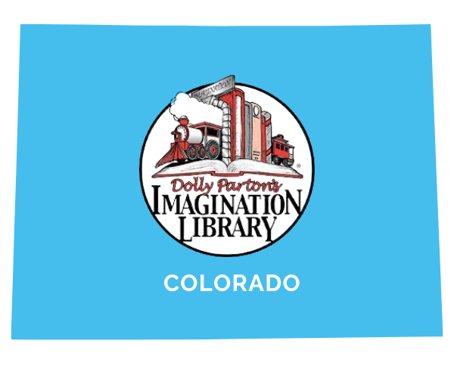

May 20, 2024

Laura Douglas

Director of Program Services

Imagination Library of Colorado

laura[@imaginationlibrarycolorado.org](mailto:jack@imaginationlibrarycolorado.org)

303-676-8012

**For Immediate Release**

**Imagination Library of Colorado Announces Statewide Enrollment Week Celebration 2024**

Join your local Colorado affiliate as we come together to host Colorado’s third annual statewide Enrollment Week to increase enrollment in Imagination Library

The Imagination Library of Colorado announced today its third annual statewide enrollment week celebration event from May 20th – 26th to promote the program’s expansion throughout Colorado. In conjunction, each local affiliate organization in Colorado will host its own celebration in their communities to raise awareness and invite new families to register children for Dolly Parton’s Imagination Library Program.

“Access to a home library not only increases early literacy rates, it fosters a love for books and promotes a culture of reading at home. While the gift of a book is simple, it has the power to change the trajectory of a child’s life,” stated Jack Tate, CEO of Imagination Library of Colorado.

Dolly Parton’s Imagination Library is dedicated to inspiring a love of reading by mailing a free book monthly to enrolled children under the age of 5. Since its launch in 1995, the program has promoted early childhood literacy across the world by helping children to become “reading ready” as they enter kindergarten.

"When I was growing up in the hills of East Tennessee, I knew my dreams would come true,” Parton said in a statement. “I know there are children in your community with their own dreams. They dream of becoming a doctor or an inventor or a minister. Who knows, maybe there is a little girl whose dream is to be a writer and singer. The seeds of these dreams are often found in books and the seeds you help plant in your community can grow across the world.”

In February, Colorado’s statewide Imagination Library program celebrated its millionth book mailed since its 2021 launch. This tremendous accomplishment wouldn’t be possible without the help of community partners, The Colorado Department of Education, The Colorado Department of Early Childhood, and local affiliates across the state.

“Thanks to Dolly, more Colorado kids tumble out of bed, stumble to the kitchen, pour themselves a cup of ambition, and read from 9 to 5! It is important that at a young age, students have access to books to foster their love of reading,” said Governor Polis.

Parents and guardians can enroll their children online to receive a new book free of charge every month by mail at [ImaginationLibraryCo](https://www.imaginationlibrarycolorado.org/local-imagination-library-locator) or in person with their local affiliate.

Those interested in learning more about the Statewide Enrollment Week Celebration or Dolly Parton’s Imagination Library in Colorado should contact the organization at (720) 819-7323, or books@imaginationlibrarycolorado.org, or visit <https://www.imaginationlibrarycolorado.org/>.

*Enrollment is open year round – if you have problems enrolling or the website says that we are not open in your community, please reach out for assistance*

###